**DAILY ONLINE ACTIVITIES SUMMARY**

|  |  |  |  |  |  |  |  |
| --- | --- | --- | --- | --- | --- | --- | --- |
| **Date:** | **13-07-2020** | | | | **Name:** | **B.A.SOHANKUMAR** | |
| **Sem & Sec** | **4TH SEM A** | | | | **USN:** | **4AL18CS013** | |
| **Online Test Summary** | | | | | | | |
| **Subject** | | **MICRO CONTROLLER AND EMBEDDED SYSTEM** | | | | | |
| **Max. Marks** | | **30** | | **Score** | | **NOT DECLARED** | |
| **Certification Course Summary** | | | | | | | |
| **Course** | **STATISTICAL METHODS FOR DECISION MAKING** | | | | | | |
| **Certificate Provider** | | | **GLA** | **Duration** | | | **7 HOURS** |
| **Coding Challenges** | | | | | | | |
| **Problem Statement:** Write a Java Program to find the duplicate characters in a string. | | | | | | | |
| **Status:EXECUTED** | | | | | | | |
| **Uploaded the report in Github** | | | | **YES** | | | |
| **If yes Repository name** | | | | **https://github.com/sohannaik5648987/DAILY-REPORTS** | | | |
| **Uploaded the report in slack** | | | | **YES** | | | |

ONLINE DESCRIPTIVE TEST:

Today there was a test on 1st module of MES.The duration of the test was 45 minutes from 09.30am to 10.15am.Questions were give and it was suppose to write in à4 size sheet and upload to the Google classroom.score was not yet declared.

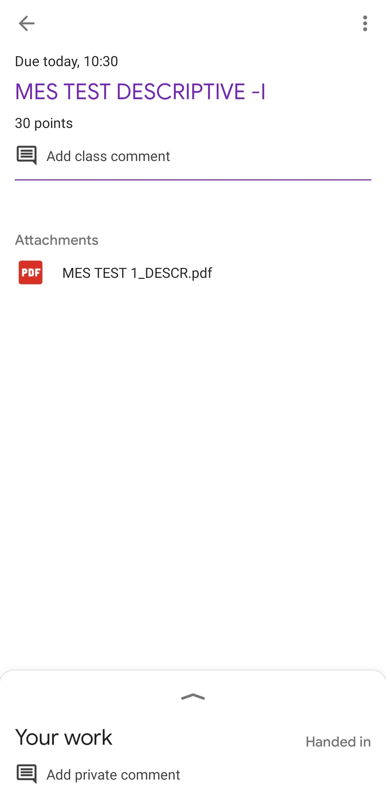

CERTIFICATION COURSE DETAILS:

Course: STATISTICAL METHOD FOR DECISION MAKING

Completed modules today are Central Limit Theorem,Hypothesis Testing,Case Study - Hypothesis Testing,Examples of Hypothesis Formulations,Working on R,Hypothesis Testing,InternetMobileTime,Luggage and successfully completed the course.

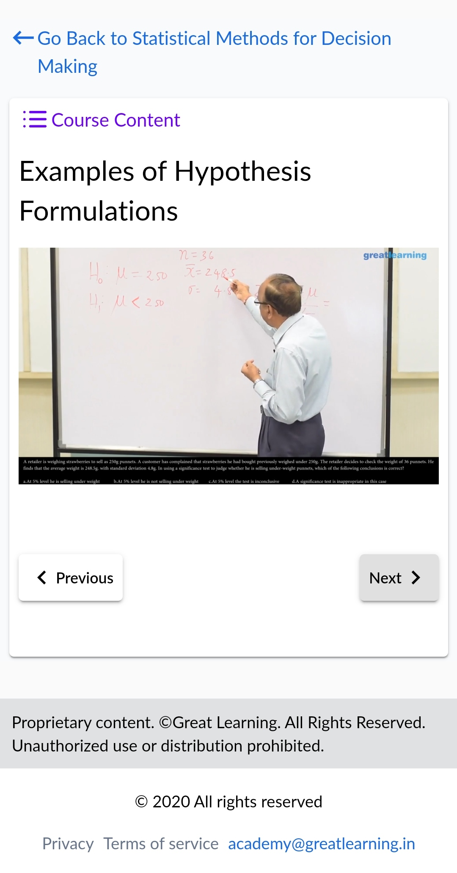 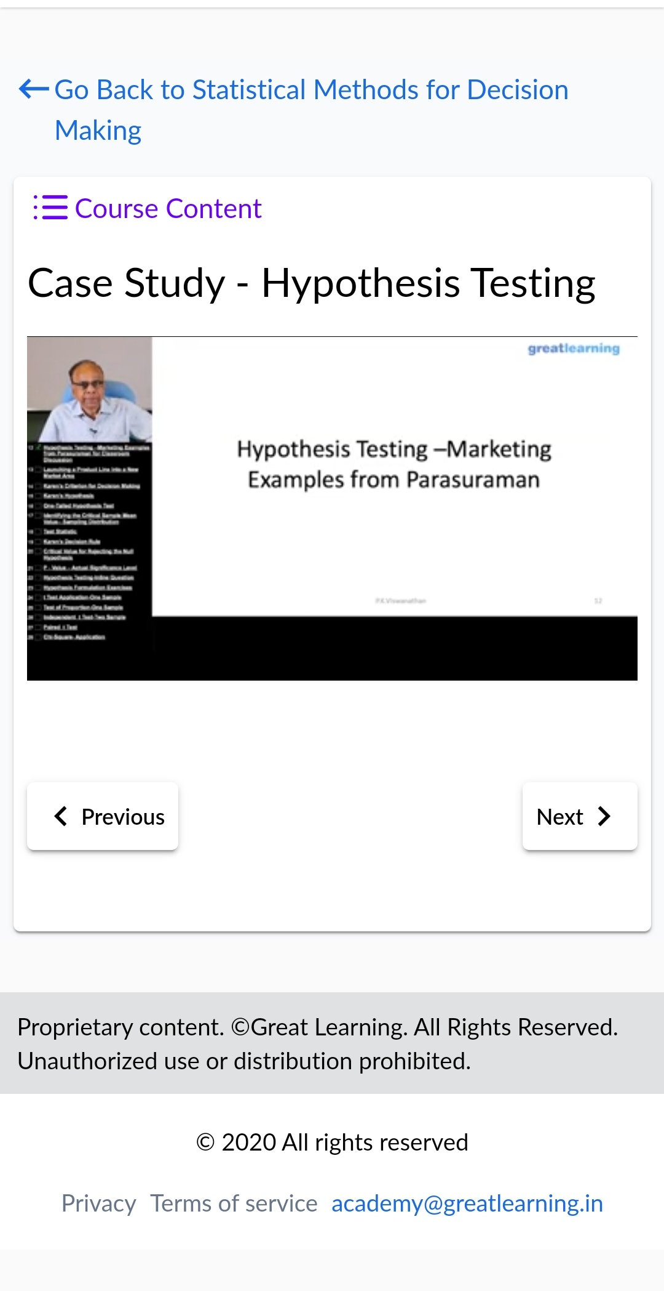

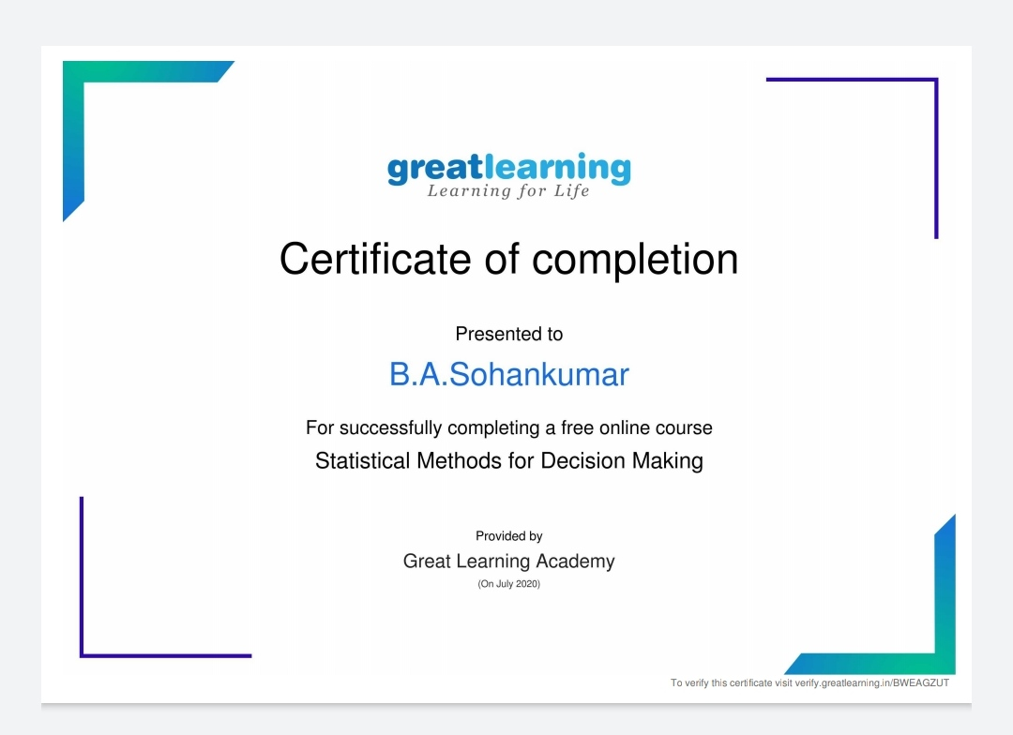

Above certificate is awarded for the completion of this course.

CODING CHALLENGES;

1.Write a Java Program to find the duplicate characters in a string.

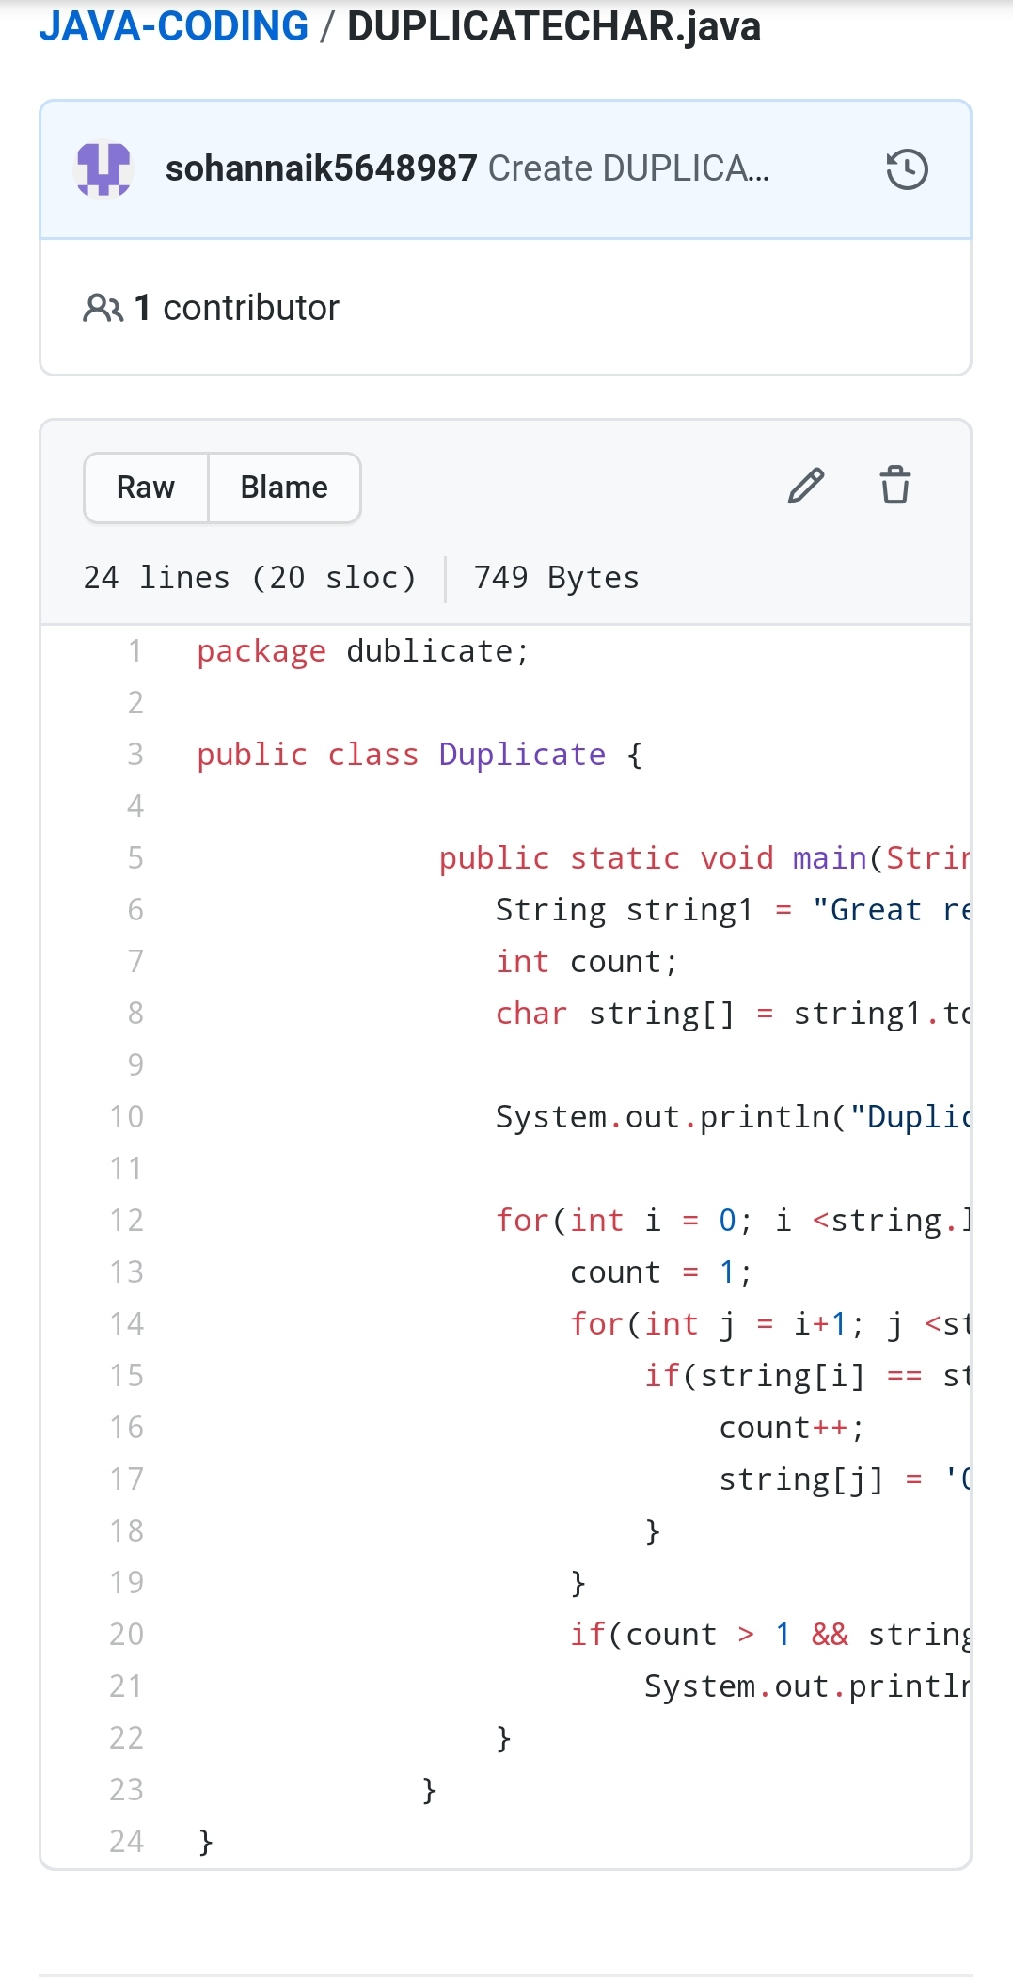

REPOSITORY LINK:https://github.com/sohannaik5648987/JAVA-CODING